**Settings**

|  |  |  |
| --- | --- | --- |
|  | **Selected** | **Observed** |
| **Language** | Spanish | Spanish |
| **Category** | Common Nouns | Common Nouns |
| **Game Difficulty** | Easy | Easy |
| **Word Difficulty** | Easy | All |
| **Format** | Foreign to English | Foreign to English |

**Screenshot**

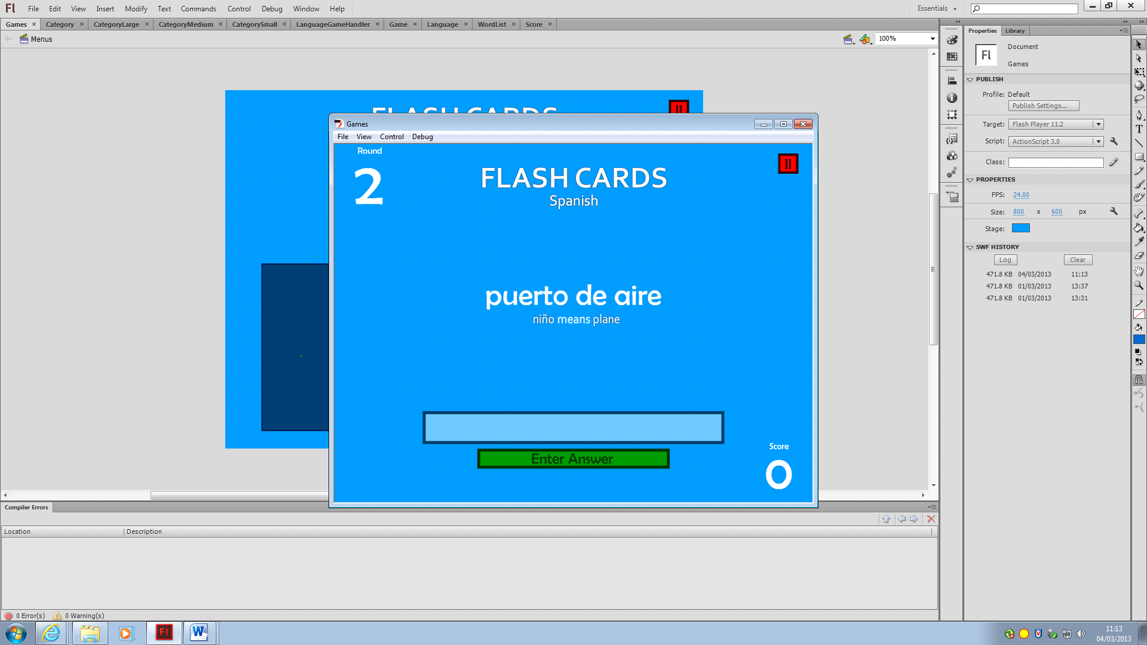

**Results**

|  |  |  |  |
| --- | --- | --- | --- |
| **Round** | **Output** | **Input** | **Translation** |
| **1** | nino | nine | plane |
| **2** | Puerto de aire | Air port | [Expected Answer] TypeError: Error #2007: Parameter text must be non-null.  at flash.text::TextField/set text()  at Games_fla::MainTimeline/respondUI()  at Games_fla::MainTimeline/giveAnswer()  at Games_fla::MainTimeline/keyHandler() |
| **3** | N/A | N/A | N/A |

**Settings**

|  |  |  |
| --- | --- | --- |
|  | **Selected** | **Observed** |
| **Language** | Spanish | Spanish |
| **Category** | Common Verbs | Common Verbs |
| **Game Difficulty** | Medium | N/A |
| **Word Difficulty** | Medium | N/A |
| **Format** | Foreign to English | Foreign to English |

**Screenshot**

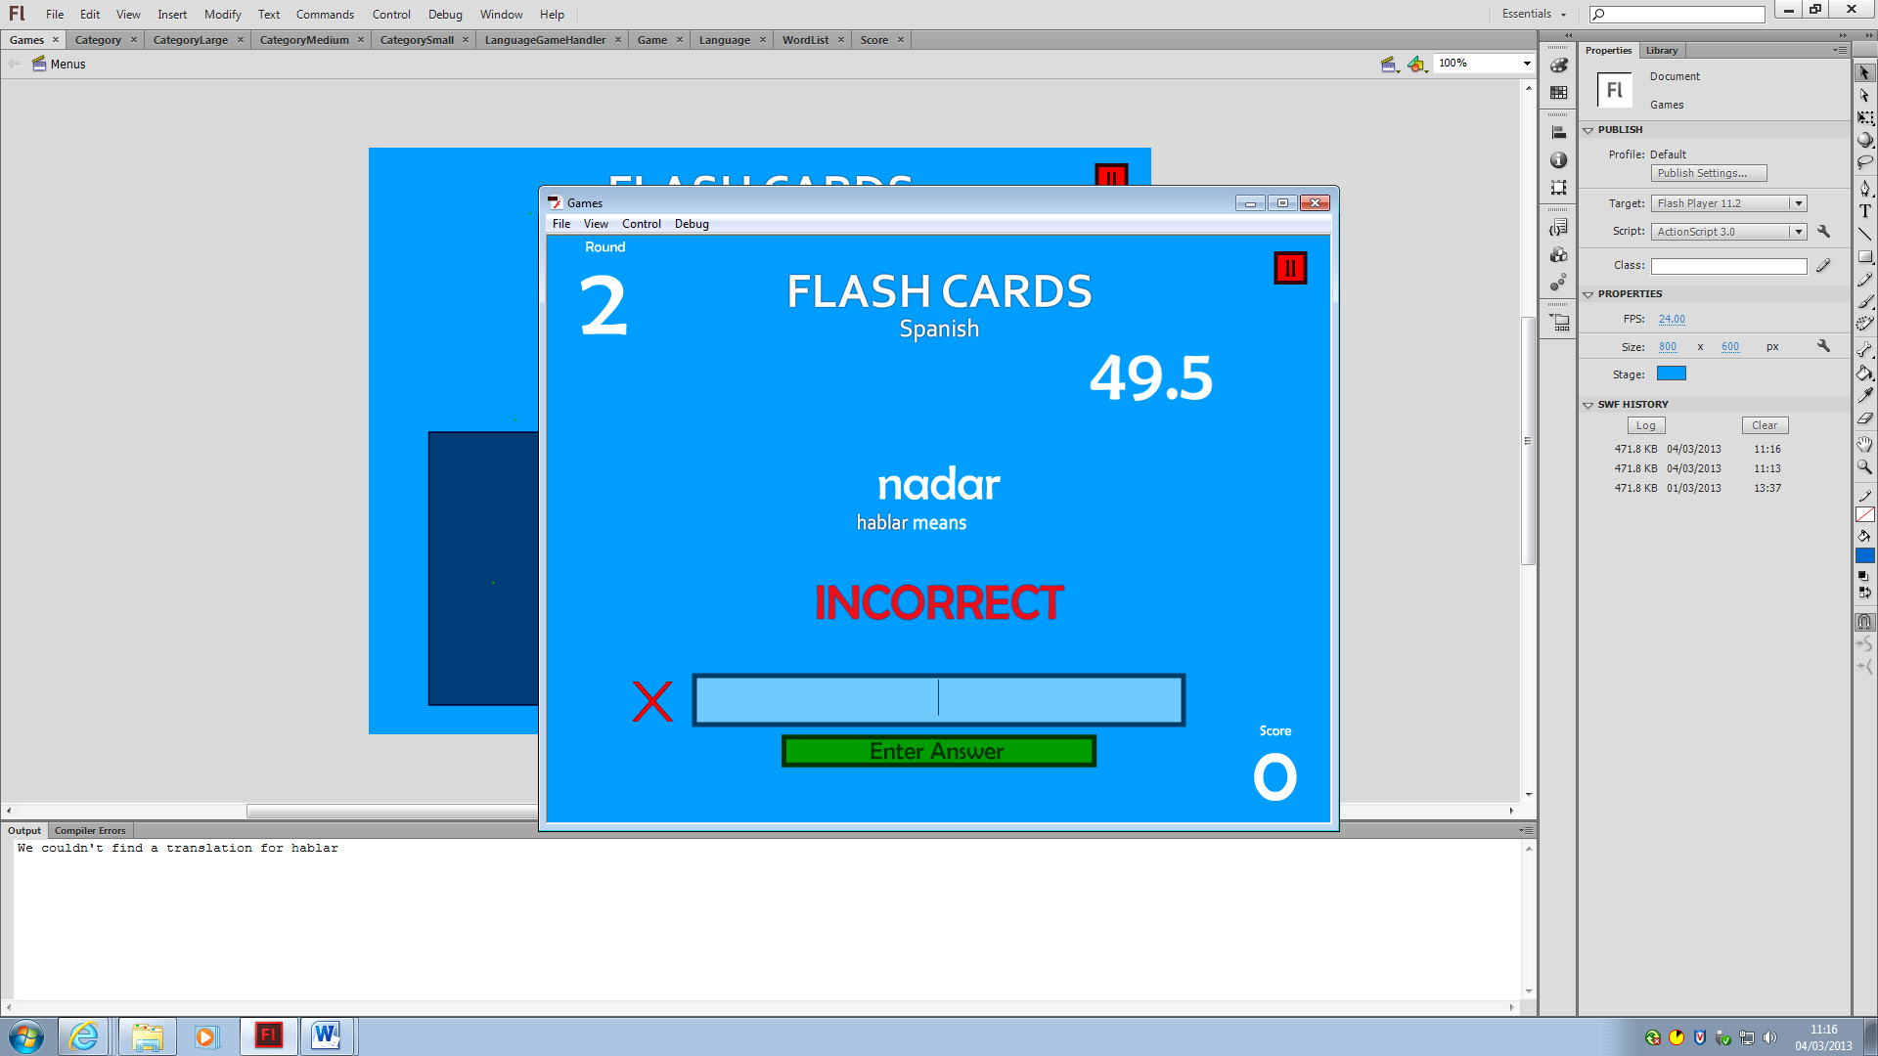

**Results**

|  |  |  |  |
| --- | --- | --- | --- |
| **Round** | **Output** | **Input** | **Translation** |
| **1** | hablar | asdf | We couldn't find a translation for hablar |
| **2** | nadar | [Nothing] | We couldn't find a translation for nadar |

**Settings**

|  |  |  |
| --- | --- | --- |
|  | **Selected** | **Observed** |
| **Language** | Spanish | Spanish |
| **Category** | Common Adjectives | Common Adjectives |
| **Game Difficulty** | Hard | N/A |
| **Word Difficulty** | Hard | All |
| **Format** | English to Foreign | Foreign to English |

**Screenshot**

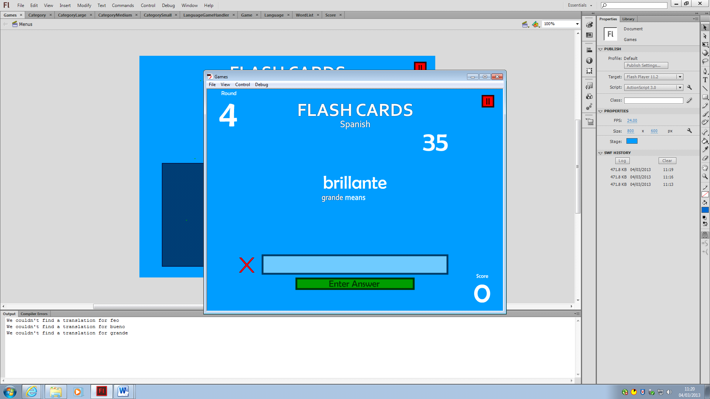

**Results**

|  |  |  |  |
| --- | --- | --- | --- |
| **Round** | **Output** | **Input** | **Translation** |
| **1** | Feo | [Nothing] | couldn't find a translation |
| **2** | Grande | [Nothing] | couldn't find a translation |
| **3** | Brilliante | [Nothing] | couldn't find a translation |

**Actions taken to resolve**

The observed bugs may have been caused by a single logical error, so I traced the entire algorithm to search for any and all unexpected results in the code.

* Traced the methods used in creating the game, and noticed that the getRandomWords function was returning more words than expected.
* Traced the getRandomWords, setWordList and getListByName functions to see if all values were as expected.
* I found that every single word list had all words added to them, regardless of the separators. This means that there is an error in the setWordsTo algorithm.
* This error was caused by the line: allWords[i].toLowerCase()=="easyList" which is never true, as a toLowerCase value would never contain the capital L in easyList.
* Correcting this error removed the values of easyList, mediumList, etc. from the wordlist, but they are still being set **all of the words**.
* It became evident upon further tracing that the getListByName method was not functioning correctly.
* The same error was found in the getListByName method, where a toLowerCase value was being compared to a string value containing an uppercase letter.
* Further investigation revealed that the list of countries, in English, was being added to the easyList in Spanish
* The problem was narrowed down further, to show that whenever there was a change in the languages being set words, there was a follow-through from the last accessed word list.
* When adding to the first word list in Spanish, an extra iteration added the words from the last word list in English, so the first list.
* This was caused by some missing code, which reset the value of the array holding the values to be added.
* Playing some more, the next problem was found when the game began, where the output box for the words simply said, “outputWord”
* This was caused by a crucial line of code was accidentally deleted earlier, which set the word list used in the game

Problems for future language implmentation:

* Change numbers to string values
* Change “commonNouns” to their respective categories
* Add the splice line to the beginning of each language

Prior to Portuguese, Finnish and Dutch being added to the game, once I was confident in the other languages working, I used a method I created called MEGAWORDTRACEGO to methodically trace all of the words in the language lists. Here is what it returned:

Language: English, Category: commonNouns, Word List: EASY, is: dog,cat,man,woman,girl,boy,car,coffee,beach,house,food,drink,me,child,bird,book,table,chair,phone,shop,bed,day,tea,tourist

Language: English, Category: commonNouns, Word List: MEDIUM, is: animal,person,waiter,sir,money,madam,plane,boat,train,bus,river,breakfast,lunch,dinner,road,dessert,desert,bathroom,name,waiter,hotel,english

Language: English, Category: commonNouns, Word List: HARD, is: elevator,apartment,grocery store,taxi,air port,train station,restaurant,building,traffic,spanish,german,italian,french,portuguese,turkish,finnish,dutch,japanese

Language: English, Category: commonVerbs, Word List: EASY, is: help,go,talk,see,get,run,walk,hear,read,buy,sell,phone

Language: English, Category: commonVerbs, Word List: MEDIUM, is: text,take,drive,wait,speak,swim,learn,sleep,give,sit,stand

Language: English, Category: commonVerbs, Word List: HARD, is: pronounce,choose,know,build,work,smell,travel,wait,feel

Language: English, Category: commonAdjectives, Word List: EASY, is: good,bad,pretty,ugly,big,small,happy,sad,cold,hot

Language: English, Category: commonAdjectives, Word List: MEDIUM, is: tired,tall,short,smart,dumb,angry,loud,quiet,fast,slow

Language: English, Category: commonAdjectives, Word List: HARD, is: bright,dark,clear,confused,annoying,rude,polite,expensive,cheap

Language: English, Category: numbers, Word List: EASY, is: zero,one,two,three,four,five,six,seven,eight,nine,ten

Language: English, Category: numbers, Word List: MEDIUM, is: twenty,thirty,forty,fifty,sixty,seventy,eighty,ninety,one hundred

Language: English, Category: numbers, Word List: HARD, is: two hundred,three hundred,four hundred,five hundred,six hundred,seven hundred,eight hundred,nine hundred,one thousand,ten thousand,one hundred thousand,one million

Language: English, Category: travel, Word List: EASY, is: house,me,buy,go,phone,shop,car,drive,walk,run,cycle,train,bus,speak,eat,drink,hotel

Language: English, Category: travel, Word List: MEDIUM, is: sir,madam,breakfast,lunch,dinner,road,travel,borrow,taxi,money,hello,boat,plane,beach

Language: English, Category: travel, Word List: HARD, is: apartment,grocery store,air port,train station,restaurant,building,traffic,direction,address,coffee,tourist

Language: English, Category: family, Word List: FIRST, is: father,mother,brother,sister,son,daughter,uncle,aunt,grandfather,grandmother,cousin,nephew,niece

Language: English, Category: family, Word List: SECOND, is:

Language: English, Category: phrases, Word List: FIRST, is: hello,good morning,good afternoon,good evening,good night,goodbye,I don't understand,my name is-,how much is-,do you speak-,where is-,how much is-,excuse me,thank you,you're welcome

Language: English, Category: phrases, Word List: SECOND, is:

Language: English, Category: activities, Word List: FIRST, is: football,tennis,basketball,hockey,golf,cricket,baseball,rugby,badminton,squash,shopping,walking,swimming,reading,horse riding,music,sunbathing,relaxing,sight seeing

Language: English, Category: activities, Word List: SECOND, is:

Language: English, Category: pronouns, Word List: MAIN, is: Amerika,kanada,İngiltere,avustralya,fransa,İspanya,meksika,brezilya,almanya,rusya,isveç,Çin,japonya,hindistan,hollanda,Mısır,İtalya,türkiye

Language: English, Category: colours, Word List: MAIN, is: Amerika,kanada,İngiltere,avustralya,fransa,İspanya,meksika,brezilya,almanya,rusya,isveç,Çin,japonya,hindistan,hollanda,Mısır,İtalya,türkiye

Language: English, Category: countries, Word List: MAIN, is: Amerika,kanada,İngiltere,avustralya,fransa,İspanya,meksika,brezilya,almanya,rusya,isveç,Çin,japonya,hindistan,hollanda,Mısır,İtalya,türkiye

Language: Spanish, Category: commonNouns, Word List: EASY, is: perro,gato,hombre,mujer,hermoso,joven,coche,café,playa,casa,comida,bebida,me,niño,ave,libro,mesa,silla,teléfono,tienda,cama,día,tazas,turista

Language: Spanish, Category: commonNouns, Word List: MEDIUM, is: animal,persona,camarero,señor,dinero,señora,plan,barco,tren,autobús,rio,desayuno,almuerzo,cena,carretera,postre,desierto,cuarto de baño,nombre,camarero,hotel,inglés

Language: Spanish, Category: commonNouns, Word List: HARD, is: ascensor,apartamento,supermercado,taxi,puerto de aire,estación de tren,restaurant,edificio,tráfico,españoles,alemán,italian,francés,portugués,turco,finlandia,dutch,japanese

Language: Spanish, Category: commonVerbs, Word List: EASY, is: ayuda,ir,hablar,ver,get,correr,paseo,escuchar,leer,comprar,vender,teléfono

Language: Spanish, Category: commonVerbs, Word List: MEDIUM, is: texto,llevar,lector,esperar,hablar,nadar,aprender,espera,dar,siéntate,de pie

Language: Spanish, Category: commonVerbs, Word List: HARD, is: pronunciar,elegir,saber,construir,trabajo,olor,viajar,esperar,sentir

Language: Spanish, Category: commonAdjectives, Word List: EASY, is: bueno,malo,bonito,feo,grande,pequeño,feliz,triste,frío,caliente

Language: Spanish, Category: commonAdjectives, Word List: MEDIUM, is: cansado,alto,corto,elegante,tonto,enojado,fuerte,tranquilo,rápido,lento

Language: Spanish, Category: commonAdjectives, Word List: HARD, is: brillante,oscuridad,claro,confuso,molesto,grosero,educado,caro,barato

Language: Spanish, Category: numbers, Word List: EASY, is: cero,uno,dos,tres,cuatro,cinco,seis,siete,ocho,nueve,diez

Language: Spanish, Category: numbers, Word List: MEDIUM, is: veinte,treinta,cuarenta,cincuenta,sesenta,setenta,ochenta,noventa,uno cien

Language: Spanish, Category: numbers, Word List: HARD, is: doscientos,trescientos,cuatrocientos,quinientos,seiscientos,setecientos,ochocientos,novecientos,mil,diez mil,ciento mil,un millón

Language: Spanish, Category: travel, Word List: EASY, is: casa,me,comprar,ir,teléfono,tienda,coche,lector,paseo,correr,ciclo,tren,autobús,hablar,comer,beber,hotel

Language: Spanish, Category: travel, Word List: MEDIUM, is: señor,señora,desayuno,almuerzo,cena,carretera,viajar,pedir prestado,taxi,dinero,hola,barco,avión,playa

Language: Spanish, Category: travel, Word List: HARD, is: apartamento,supermercado,puerto de aire,estación de tren,restaurant,edificio,tráfico,dirección,dirección,café,turista

Language: Spanish, Category: family, Word List: FIRST, is: padre,madre,hermano,hermana,hijo,hija,tío,tía,abuelo,abuela,primo,sobrino,sobrina

Language: Spanish, Category: family, Word List: SECOND, is:

Language: Spanish, Category: phrases, Word List: FIRST, is: hola,buenos días,buenas tardes,buenas tardes,buenas noches,adiós,no entiendo,mi nombre es-,cuánto es-,hacer hablar-,¿dónde está-,cuánto es-,perdón,gracias,de nada

Language: Spanish, Category: phrases, Word List: SECOND, is:

Language: Spanish, Category: activities, Word List: FIRST, is: deporte,tenis,baloncesto,hockey,golf,grillo,pelota,rugby,bádminton,calabaza,compras,paseo,piscina,leer,montar a caballo,música,tomar el sol,relajarse,turismo

Language: Spanish, Category: activities, Word List: SECOND, is:

Language: Spanish, Category: pronouns, Word List: MAIN, is: Amerika,kanada,İngiltere,avustralya,fransa,İspanya,meksika,brezilya,almanya,rusya,isveç,Çin,japonya,hindistan,hollanda,Mısır,İtalya,türkiye

Language: Spanish, Category: colours, Word List: MAIN, is: Amerika,kanada,İngiltere,avustralya,fransa,İspanya,meksika,brezilya,almanya,rusya,isveç,Çin,japonya,hindistan,hollanda,Mısır,İtalya,türkiye

Language: Spanish, Category: countries, Word List: MAIN, is: Amerika,kanada,İngiltere,avustralya,fransa,İspanya,meksika,brezilya,almanya,rusya,isveç,Çin,japonya,hindistan,hollanda,Mısır,İtalya,türkiye

Language: French, Category: commonNouns, Word List: EASY, is: chien,chat,homme,femme,fille,enfant,voiture,chaud,plage,maison,cuisine,boisson ,moi,enfant,oiseau,livre,table,chaise,téléphone,magasin,lit,jour,vert,touriste

Language: French, Category: commonNouns, Word List: MEDIUM, is: animal,personne,serveur,monsieur,argent,madame,avion,bateau,train,bus,fleuve,petit-déjeuner,repas,souper,route,dessert,désert,sallede bain,nom,serveur,hôtel,anglais

Language: French, Category: commonNouns, Word List: HARD, is: ascenseur,appartement,épicerie,taxi,port d'air,gare,restaurant,ciel,trafic,espagnol,allemand,italie,français,portugais,turque,finlandais,hollandais,japonais

Language: French, Category: commonVerbs, Word List: EASY, is: aider,aller,parler,voir,obtenir,courir,marcher,entendre,lire,acheter,vendre,téléphone

Language: French, Category: commonVerbs, Word List: MEDIUM, is: texte,prendre,disque,attendre,parler,nager,apprendre,sommeil,donner,assis,debout

Language: French, Category: commonVerbs, Word List: HARD, is: prononcer,choisir,savoir,construire,travail,odeur,voyage,attendre,sentir

Language: French, Category: commonAdjectives, Word List: EASY, is: bon,mauvais,joli,laid,grand,petit,heureux,triste,froid,chaud

Language: French, Category: commonAdjectives, Word List: MEDIUM, is: fatigué,grandiose,court,portrait,muet,en colère,fort,calme,rapide,lent

Language: French, Category: commonAdjectives, Word List: HARD, is: lumineux,noir,clair,confus,ennuyeux,rude,poli,cher,pas cher

Language: French, Category: numbers, Word List: EASY, is: zéro,un,deux,trois,quatre,cinq,six,sept,huit,neuf,dix

Language: French, Category: numbers, Word List: MEDIUM, is: vingt,trente,quarante,cinquante,soixante,soixante,quatre-vingts,quatre-vingt-dix,cent

Language: French, Category: numbers, Word List: HARD, is: deux cents,trois cents,quatre cent,cinq cents,six cents,sept cents,huit cents,neuf cent,mille,dix mille,cent mille,un million

Language: French, Category: travel, Word List: EASY, is: maison,moi,acheter,go,téléphone,magasin,voiture,conduire,marche,courir,faire du vélo,train,bus,parler,manger,boisson,hôtel

Language: French, Category: travel, Word List: MEDIUM, is: monsieur,madame,petit,repas,souper,route,voyage,emprunter,taxi,argent,bonjour,bateau , plan , plage

Language: French, Category: travel, Word List: HARD, is: appartement,épicerie,port d'air,gare,restaurant,ciel,trafic,direction,adresse,chaud,touriste

Language: French, Category: family, Word List: FIRST, is: père,mère,frère,sœur,fils,fille,oncle,tante,grand-père,grand-mère,cousin,neveu,nièce

Language: French, Category: family, Word List: SECOND, is:

Language: French, Category: phrases, Word List: FIRST, is: bonjour,bonjour,bon après-midi,bonsoir,bonne nuit,au revoir,je ne comprends pas,mon nom est-,combien est-,parlez-vous-,où est-,combien est-,excusez-moi,merci,vous êtes les bienvenus

Language: French, Category: phrases, Word List: SECOND, is:

Language: French, Category: activities, Word List: FIRST, is: football,tennis,basket-ball,hockey,golf,cricket,base-ball,rugby,badminton,courge,achats,marche,baignade,lecture,cheval,musique,bain de soleil,relaxant,voir de vue

Language: French, Category: activities, Word List: SECOND, is:

Language: French, Category: pronouns, Word List: MAIN, is: Amerika,kanada,İngiltere,avustralya,fransa,İspanya,meksika,brezilya,almanya,rusya,isveç,Çin,japonya,hindistan,hollanda,Mısır,İtalya,türkiye

Language: French, Category: colours, Word List: MAIN, is: Amerika,kanada,İngiltere,avustralya,fransa,İspanya,meksika,brezilya,almanya,rusya,isveç,Çin,japonya,hindistan,hollanda,Mısır,İtalya,türkiye

Language: French, Category: countries, Word List: MAIN, is: Amerika,kanada,İngiltere,avustralya,fransa,İspanya,meksika,brezilya,almanya,rusya,isveç,Çin,japonya,hindistan,hollanda,Mısır,İtalya,türkiye

Language: Italian, Category: commonNouns, Word List: EASY, is: cane,gatto,uomo,donna,ragazza,ragazzo,auto,caffè,spiaggia,casa,alimento,bere,me,bambino,bianco,libro,tavolo,sedia,telefono,negozio,letto,giornata,tazza,turista

Language: Italian, Category: commonNouns, Word List: MEDIUM, is: animale,persona,cameriere,signore,denaro,signora,piano,barca,treno,autobus,fiume,colazione,pranzo,cena,strada,dessert,desertico,bagno,nome,cameriere,albergo,inglese

Language: Italian, Category: commonNouns, Word List: HARD, is: ascensore,appartamento,negozio,taxi,aria porto,stazione ferroviaria,ristorante,costruzione,traffico,spagnolo,tedesco,italiano,francese,portoghese,turco,finlandese,olandese,giapponese

Language: Italian, Category: commonVerbs, Word List: EASY, is: aiuto,andare,parlare,vedere,ottenere,correre,camminare,ascoltare,leggere,acquistare,vendere,telefono

Language: Italian, Category: commonVerbs, Word List: MEDIUM, is: testo,prendere,guida,aspettare,parlare,nuotare,imparare,sonno,dare,sedersi,stare in piedi

Language: Italian, Category: commonVerbs, Word List: HARD, is: pronunciare,scegliere,conoscere,costruire,lavoro,odore,viaggio,aspettare,sentire

Language: Italian, Category: commonAdjectives, Word List: EASY, is: buono,cattivo,ragazza,brutto,grande,piccolo,felice,triste,freddo,caldo

Language: Italian, Category: commonAdjectives, Word List: MEDIUM, is: stanco,alto,breve,intelligente,stupido,arrabbiato,forte,tranquillo,veloce,lento

Language: Italian, Category: commonAdjectives, Word List: HARD, is: brillante,scuro,chiaro,confuso,fastidioso,scortese,gentile,costoso,economico

Language: Italian, Category: numbers, Word List: EASY, is: zero,uno,due,tre,quattro,cinque,sei,sette,otto,nove,dieci

Language: Italian, Category: numbers, Word List: MEDIUM, is: venti,trenta,quaranta,cinquanta,sessanta,settanta,ottanta,novanta,cento

Language: Italian, Category: numbers, Word List: HARD, is: duecento,trecento,quattrocento,cinquecento,seicento,settecento,ottocento,novecento,mille,diecimila,centomila,milione

Language: Italian, Category: travel, Word List: EASY, is: casa,me,compro,andare,telefono,negozio,auto,guidare,camminata,correre,ciclo,treno,autobus,parlare,mangiare,bere,albergo

Language: Italian, Category: travel, Word List: MEDIUM, is: signore,signora,colazione,pranzo,cena,strada,viaggio,prendere in prestito,taxi,denaro,ciao,barca,piano,spiaggia

Language: Italian, Category: travel, Word List: HARD, is: appartamento,negozio,aria porto,stazione,ristorante,costruzione,traffico,direzione,indirizzo,caffè,turista

Language: Italian, Category: family, Word List: FIRST, is: padre,madre,fratello,sorella,figlio,figlia,zio,zia,nonno,nonna,cugino,nipote,nipotina

Language: Italian, Category: family, Word List: SECOND, is:

Language: Italian, Category: phrases, Word List: FIRST, is: ciao,buongiorno,buon pomeriggio,buonasera,buona notte,arrivederci,non capisco,il mio nome è-,quanto è-,fai-Speak,dove è-,quanto è-,mi scusi,grazie,sei il benvenuto

Language: Italian, Category: phrases, Word List: SECOND, is:

Language: Italian, Category: activities, Word List: FIRST, is: calcio,tennis,pallacanestro,hockey,golf,grillo,baseball,rugby,volano,squash,acquisti,camminare,nuotare,lettura,cavallo,musica,prendere il sole,rilassante,giri turistici

Language: Italian, Category: activities, Word List: SECOND, is:

Language: Italian, Category: pronouns, Word List: MAIN, is: Amerika,kanada,İngiltere,avustralya,fransa,İspanya,meksika,brezilya,almanya,rusya,isveç,Çin,japonya,hindistan,hollanda,Mısır,İtalya,türkiye

Language: Italian, Category: colours, Word List: MAIN, is: Amerika,kanada,İngiltere,avustralya,fransa,İspanya,meksika,brezilya,almanya,rusya,isveç,Çin,japonya,hindistan,hollanda,Mısır,İtalya,türkiye

Language: Italian, Category: countries, Word List: MAIN, is: Amerika,kanada,İngiltere,avustralya,fransa,İspanya,meksika,brezilya,almanya,rusya,isveç,Çin,japonya,hindistan,hollanda,Mısır,İtalya,türkiye

Language: German, Category: commonNouns, Word List: EASY, is: hund,katze,mann,frau,frau,junge,auto,kaffee,strand,haus,essen,trinken,mir,kind,vogel,buch,tisch,stuhl,telefon,geschäft,bett,tag,tee,tourist

Language: German, Category: commonNouns, Word List: MEDIUM, is: animal,person,kellner,herr,geld,frau,plane,boot,trainieren,bus,fluss,frühstück,lunch,essen,straße,essen,wüste,badezimmer,name,kellner,hotel,englisch

Language: German, Category: commonNouns, Word List: HARD, is: aufzug,wohnung,supermarkt,taxi,luft-port,bahnhof,restaurant,entwerfen,verkehr,spanisch,deutsch,italienisch,französisch,portugiesisch,türkisch,finnisch,holland,japanisch

Language: German, Category: commonVerbs, Word List: EASY, is: hilfe,gehen,sprechen,sehen,bekommen,laufen,laufen,hören,lesen,kaufen,verkaufen,telefon

Language: German, Category: commonVerbs, Word List: MEDIUM, is: text,nehmen,fahren,warten,sprechen,schwimmen,lernen,schlafen,geben,sitzen,stehen

Language: German, Category: commonVerbs, Word List: HARD, is: sprechen,entscheiden,wissen,bauen,arbeit,geruch,reisen,warten,fühlen

Language: German, Category: commonAdjectives, Word List: EASY, is: gut,schlecht,schön,hässlich,groß,klein,glücklich,traurig,kalt,heiß

Language: German, Category: commonAdjectives, Word List: MEDIUM, is: müde,hoch,kurz,pfiffig,dumm,aufgebracht,laut,ruhig,schnell,langsam

Language: German, Category: commonAdjectives, Word List: HARD, is: hell,dunkel,klar,verwirrt,ärgerlich,unhöflich,höflich,teuer,billig

Language: German, Category: numbers, Word List: EASY, is: null,eins,zwei,drei,vier,fünf,sechs,sieben,acht,neun,zehn

Language: German, Category: numbers, Word List: MEDIUM, is: 20,30,40,50,60,70,80,90,hundert

Language: German, Category: numbers, Word List: HARD, is: 200,300,400,500,600,700,800,900,tausend,zehntausend,hunderttausend,million

Language: German, Category: travel, Word List: EASY, is: haus,mir,kaufen,gehen,telefon,geschäft,auto,fahren,gehen,laufen,radeln,zug,bus,sprechen,essen,trinken,hotel

Language: German, Category: travel, Word List: MEDIUM, is: herr,frau,frühstück,mittagessen,abendessen,reisen,reisen,borgen,taxi,geld,hallo,boot,flugzeug,strand

Language: German, Category: travel, Word List: HARD, is: wohnung,supermarkt,luft-port,bahnhof,restaurant,entwerfen,verkehr,richtung,adresse,kaffee,tourist

Language: German, Category: family, Word List: FIRST, is: vater,mutter,bruder,schwester,sohn,tochter,onkel,tante,großvater,großmutter,cousin,neffe,nichte

Language: German, Category: family, Word List: SECOND, is:

Language: German, Category: phrases, Word List: FIRST, is: hallo,guten morgen,guten tag,guten abend,gute nacht,auf wiedersehen,ich verstehe nicht,mein name ist-,wie viel-,sprechen sie-,wo ist-,wie viel ist-,excuse me,danke,du bist willkommen

Language: German, Category: phrases, Word List: SECOND, is:

Language: German, Category: activities, Word List: FIRST, is: ball,tennis,korbball,eishockey,golf,kricket,baseball,rugby,federball,squash,einkaufen,fuß,schwimmen,lesen,reiten,musik,sonnen,entspannt,besichtigung

Language: German, Category: activities, Word List: SECOND, is:

Language: German, Category: pronouns, Word List: MAIN, is: Amerika,kanada,İngiltere,avustralya,fransa,İspanya,meksika,brezilya,almanya,rusya,isveç,Çin,japonya,hindistan,hollanda,Mısır,İtalya,türkiye

Language: German, Category: colours, Word List: MAIN, is: Amerika,kanada,İngiltere,avustralya,fransa,İspanya,meksika,brezilya,almanya,rusya,isveç,Çin,japonya,hindistan,hollanda,Mısır,İtalya,türkiye

Language: German, Category: countries, Word List: MAIN, is: Amerika,kanada,İngiltere,avustralya,fransa,İspanya,meksika,brezilya,almanya,rusya,isveç,Çin,japonya,hindistan,hollanda,Mısır,İtalya,türkiye

Language: Japanese, Category: commonNouns, Word List: EASY, is: inu,neko,dansei,josei,on'nanoko,otokonoko,kuruma,kōhī,bīchi,jūtaku,shokuhin,inryō,watashi,kodomo,tori,hon,tēburu,isu,denwa,shoppu,beddo,hi,cha,kankō

Language: Japanese, Category: commonNouns, Word List: MEDIUM, is: dōbutsu,hito,u~eitā,sā,okane,madamu,hikōki,bōto,densha,basu,kawa,chōshoku ,chūshoku,yūshoku,dōro,dezāto,sabaku,yokushitsu,namae,ueitā,hoteru,eigo

Language: Japanese, Category: commonNouns, Word List: HARD, is: erebētā,manshon,shokuryōhin-ten,takushī,eāpōto,-eki,resutoran,tatemono,torafikku,supeingo,doitsugo,itaria-go,furansugo,porutogaru-go,nihongo,oranda,finrando,toruko

Language: Japanese, Category: commonVerbs, Word List: EASY, is: uru,kau,geitaidenwa o yomu,kiku,aruku,jikkō,shutoku,miru,tōku,iku,herupu

Language: Japanese, Category: commonVerbs, Word List: MEDIUM, is: tekisuto,tatsu,suwaru,ataeru,manabu,oyogu,hanasu,suimin,matsu,doraibu o toru

Language: Japanese, Category: commonVerbs, Word List: HARD, is: kōchiku,shitte iru,sentaku,shigoto,kaori,ryokō,taiki,hatsuon,kanjiru

Language: Japanese, Category: commonAdjectives, Word List: EASY, is: yoi,warui,atsui,samui,kanashī,ureshī,ko,dai,minikui,kirei

Language: Japanese, Category: commonAdjectives, Word List: MEDIUM, is: osoi,hayai,shizuka,sōzōshī,ikari,damu,sumāto,shōto,senotakai,tsukareta

Language: Japanese, Category: commonAdjectives, Word List: HARD, is: yasui,kōka,reigi tadashī,shitsurei,urusai,konran,kuria,kurai,akarui

Language: Japanese, Category: numbers, Word List: EASY, is: zero,ichi,ni,yon,shi,go,roku,nana,hachi,kyu,juu

Language: Japanese, Category: numbers, Word List: MEDIUM, is: nijuu,sanjuu,yonjuu,gojuu,rokujuu,nanajuu,hachijuu,kyujuu,hyaku

Language: Japanese, Category: numbers, Word List: HARD, is: nihyaku,sanbyaku,yonhyaku,gohyaku,roppyaku,nanhyaku,happyaku,kyuhyaku,sen,man,mansen,sensen

Language: Japanese, Category: travel, Word List: EASY, is: ie,watashi,kau,iku,denwa,shoppu,kuruma,doraibu,sanpo,jikkō,saikuru,ressha,basu,hanasu,taberu,nomu,hoteru

Language: Japanese, Category: travel, Word List: MEDIUM, is: sensei,madamu,chōshoku,chūshoku,yūshoku,dōro,ryokō,kariru,takushī,okane,kon'nichiwa,bōto,hikōki,bīchi

Language: Japanese, Category: travel, Word List: HARD, is: manshon,shokuryōhin-ten,eāpōto,tetsudō no eki,resutoran,tatemono,torafikku,hōkō,adoresu,kōhī,kankōkyaku

Language: Japanese, Category: family, Word List: FIRST, is: chichi,haha,otōto,imōto,musuko,musume,oji,oba,sofu,sobo,itoko,oi,mei

Language: Japanese, Category: family, Word List: SECOND, is:

Language: Japanese, Category: phrases, Word List: FIRST, is: kon'nichiwa,ohayō,kon'nichiwa,konbanwa,oyasumi,sayonara,watashi wa rikai shite inai,Watashinonamaeha-,-wa dono kurai,hanasu - anata wa nan,doko ni aru-,ikuradesu ka-,dōitashimashite,arigatō,sumimasen

Language: Japanese, Category: phrases, Word List: SECOND, is:

Language: Japanese, Category: activities, Word List: FIRST, is: sakkā,tenisu,basukettobōru,hokkē,gorufu,kuriketto,yakyū,ragubī,badominton,sukasshu,kaimono,u~ōkingu,suiei,dokusho,shiryoku ga mite,rirakkusu,nikkōyoku,ongaku,jōba

Language: Japanese, Category: activities, Word List: SECOND, is:

Language: Japanese, Category: pronouns, Word List: MAIN, is: Amerika,kanada,İngiltere,avustralya,fransa,İspanya,meksika,brezilya,almanya,rusya,isveç,Çin,japonya,hindistan,hollanda,Mısır,İtalya,türkiye

Language: Japanese, Category: colours, Word List: MAIN, is: Amerika,kanada,İngiltere,avustralya,fransa,İspanya,meksika,brezilya,almanya,rusya,isveç,Çin,japonya,hindistan,hollanda,Mısır,İtalya,türkiye

Language: Japanese, Category: countries, Word List: MAIN, is: Amerika,kanada,İngiltere,avustralya,fransa,İspanya,meksika,brezilya,almanya,rusya,isveç,Çin,japonya,hindistan,hollanda,Mısır,İtalya,türkiye

Language: Finnish, Category: commonNouns, Word List: EASY, is:

Language: Finnish, Category: commonNouns, Word List: MEDIUM, is:

Language: Finnish, Category: commonNouns, Word List: HARD, is:

Language: Finnish, Category: commonVerbs, Word List: EASY, is:

Language: Finnish, Category: commonVerbs, Word List: MEDIUM, is:

Language: Finnish, Category: commonVerbs, Word List: HARD, is:

Language: Finnish, Category: commonAdjectives, Word List: EASY, is:

Language: Finnish, Category: commonAdjectives, Word List: MEDIUM, is:

Language: Finnish, Category: commonAdjectives, Word List: HARD, is:

Language: Finnish, Category: numbers, Word List: EASY, is:

Language: Finnish, Category: numbers, Word List: MEDIUM, is:

Language: Finnish, Category: numbers, Word List: HARD, is:

Language: Finnish, Category: travel, Word List: EASY, is:

Language: Finnish, Category: travel, Word List: MEDIUM, is:

Language: Finnish, Category: travel, Word List: HARD, is:

Language: Finnish, Category: family, Word List: FIRST, is:

Language: Finnish, Category: family, Word List: SECOND, is:

Language: Finnish, Category: phrases, Word List: FIRST, is:

Language: Finnish, Category: phrases, Word List: SECOND, is:

Language: Finnish, Category: activities, Word List: FIRST, is:

Language: Finnish, Category: activities, Word List: SECOND, is:

Language: Finnish, Category: pronouns, Word List: MAIN, is:

Language: Finnish, Category: colours, Word List: MAIN, is:

Language: Finnish, Category: countries, Word List: MAIN, is:

Language: Turkish, Category: commonNouns, Word List: EASY, is: köpek,kedi,adam,kadın,kız,çocuk,araba,kahve,plaj,ev,yiyecek,içki,bana,çocuk,kuş,kitap,masa,sandalye,telefon,alışveriş,yatak,gün,çay,turist

Language: Turkish, Category: commonNouns, Word List: MEDIUM, is: hayvan,insan,garson,efendim,para,hanımefendi,uçak,tekne,tren,Otobüs,nehir,kahvaltı,yemek,yemek,yol,tatlı,çöl,banyo,isim,garson,otel,İngilizce

Language: Turkish, Category: commonNouns, Word List: HARD, is: asansör,daire,bakkal,taksi,hava limanı,tren istasyonu,restoran,bina,trafik,ispanyolca,almanca,İtalyan,fransız,portekizce,japon,hollanda,fin,türk

Language: Turkish, Category: commonVerbs, Word List: EASY, is: satmak,satın alma,telefon,okumak,duymak,yürüyüş,koşmak,almak,görmek,konuşma,gitmek,yardım

Language: Turkish, Category: commonVerbs, Word List: MEDIUM, is: metin,ayakta,oturmak,vermek,öğrenme,yüzmek,konuşma,uyku,beklemek,sürücü,almak

Language: Turkish, Category: commonVerbs, Word List: HARD, is: inşa,bilmek,tercih,iş,koku,seyahat etmek,beklemek,telaffuz,hissediyorum

Language: Turkish, Category: commonAdjectives, Word List: EASY, is: iyi,kötü,sıcak,soğuk,üzücü,mutlu,küçük,büyük,çirkin,sevimli

Language: Turkish, Category: commonAdjectives, Word List: MEDIUM, is: yavaş,hızlı,sakin,yüksek sesle,öfkeli,aptal,akıllı,kısa,uzun boylu,yorgun

Language: Turkish, Category: commonAdjectives, Word List: HARD, is: ucuz,pahalı,nazik,kaba,can sıkıcı,karışık,clear,koyu,parlak

Language: Turkish, Category: numbers, Word List: EASY, is: sıfır,bir,iki,üç,dört,beş,altı,yedi,sekiz,dokuz,on

Language: Turkish, Category: numbers, Word List: MEDIUM, is: doksan,yüz,seksen,yetmiş,altmış,elli,kırk,yirmi,otuz

Language: Turkish, Category: numbers, Word List: HARD, is: iki yüz,üç yüz,dört yüz,beş yüz,altı yüz,yedi yüz,sekiz yüz,dokuz yüz,bin,on bin,yüz bin,bir milyon

Language: Turkish, Category: travel, Word List: EASY, is: ev,bana,gitmek,telefon,alışveriş,araba,sürücü,yürüyüş,çalıştırmak,döngü,tren,satın,otobüs,konuşma,yemek,içki,otel

Language: Turkish, Category: travel, Word List: MEDIUM, is: efendim,hanımefendi,kahvaltı,yemek,yemek,yol,seyahat etmek,ödünç,taksi,para,merhaba,tekne,uçak,plaj

Language: Turkish, Category: travel, Word List: HARD, is: daire,bakkal,hava limanı,tren istasyonu,restoran,bina,trafik,yön,adres,kahve,turist

Language: Turkish, Category: family, Word List: FIRST, is: baba,anne,kardeş,kız kardeş,oğlum,kızım,amca,teyze,dede,büyükanne,kuzen,yeğen,yeğen

Language: Turkish, Category: family, Word List: SECOND, is:

Language: Turkish, Category: phrases, Word List: FIRST, is: merhaba,günaydın,iyi günler,iyi akşamlar,iyi geceler,güle güle,benim adım-,anlamıyorum,-ne kadar,konuşma-sen yaparsın,nerede-,ne kadar-,bir şey değil,teşekkür ederim,affedersiniz

Language: Turkish, Category: phrases, Word List: SECOND, is:

Language: Turkish, Category: activities, Word List: FIRST, is: futbol,tenis,basket,hokey,golf,kriket,beyzbol,rugby,badminton,kabak,alışveriş,yürüyüş,yüzme,okuma,görme görme,rahatlatıcı,güneşlenmek,müzik,binicilik

Language: Turkish, Category: activities, Word List: SECOND, is:

Language: Turkish, Category: pronouns, Word List: MAIN, is: Amerika,kanada,İngiltere,avustralya,fransa,İspanya,meksika,brezilya,almanya,rusya,isveç,Çin,japonya,hindistan,hollanda,Mısır,İtalya,türkiye

Language: Turkish, Category: colours, Word List: MAIN, is: Amerika,kanada,İngiltere,avustralya,fransa,İspanya,meksika,brezilya,almanya,rusya,isveç,Çin,japonya,hindistan,hollanda,Mısır,İtalya,türkiye

Language: Turkish, Category: countries, Word List: MAIN, is: Amerika,kanada,İngiltere,avustralya,fransa,İspanya,meksika,brezilya,almanya,rusya,isveç,Çin,japonya,hindistan,hollanda,Mısır,İtalya,türkiye

Language: Dutch, Category: commonNouns, Word List: EASY, is:

Language: Dutch, Category: commonNouns, Word List: MEDIUM, is:

Language: Dutch, Category: commonNouns, Word List: HARD, is:

Language: Dutch, Category: commonVerbs, Word List: EASY, is:

Language: Dutch, Category: commonVerbs, Word List: MEDIUM, is:

Language: Dutch, Category: commonVerbs, Word List: HARD, is:

Language: Dutch, Category: commonAdjectives, Word List: EASY, is:

Language: Dutch, Category: commonAdjectives, Word List: MEDIUM, is:

Language: Dutch, Category: commonAdjectives, Word List: HARD, is:

Language: Dutch, Category: numbers, Word List: EASY, is:

Language: Dutch, Category: numbers, Word List: MEDIUM, is:

Language: Dutch, Category: numbers, Word List: HARD, is:

Language: Dutch, Category: travel, Word List: EASY, is:

Language: Dutch, Category: travel, Word List: MEDIUM, is:

Language: Dutch, Category: travel, Word List: HARD, is:

Language: Dutch, Category: family, Word List: FIRST, is:

Language: Dutch, Category: family, Word List: SECOND, is:

Language: Dutch, Category: phrases, Word List: FIRST, is:

Language: Dutch, Category: phrases, Word List: SECOND, is:

Language: Dutch, Category: activities, Word List: FIRST, is:

Language: Dutch, Category: activities, Word List: SECOND, is:

Language: Dutch, Category: pronouns, Word List: MAIN, is:

Language: Dutch, Category: colours, Word List: MAIN, is:

Language: Dutch, Category: countries, Word List: MAIN, is:

Language: Portuguese, Category: commonNouns, Word List: EASY, is:

Language: Portuguese, Category: commonNouns, Word List: MEDIUM, is:

Language: Portuguese, Category: commonNouns, Word List: HARD, is:

Language: Portuguese, Category: commonVerbs, Word List: EASY, is:

Language: Portuguese, Category: commonVerbs, Word List: MEDIUM, is:

Language: Portuguese, Category: commonVerbs, Word List: HARD, is:

Language: Portuguese, Category: commonAdjectives, Word List: EASY, is:

Language: Portuguese, Category: commonAdjectives, Word List: MEDIUM, is:

Language: Portuguese, Category: commonAdjectives, Word List: HARD, is:

Language: Portuguese, Category: numbers, Word List: EASY, is:

Language: Portuguese, Category: numbers, Word List: MEDIUM, is:

Language: Portuguese, Category: numbers, Word List: HARD, is:

Language: Portuguese, Category: travel, Word List: EASY, is:

Language: Portuguese, Category: travel, Word List: MEDIUM, is:

Language: Portuguese, Category: travel, Word List: HARD, is:

Language: Portuguese, Category: family, Word List: FIRST, is:

Language: Portuguese, Category: family, Word List: SECOND, is:

Language: Portuguese, Category: phrases, Word List: FIRST, is:

Language: Portuguese, Category: phrases, Word List: SECOND, is:

Language: Portuguese, Category: activities, Word List: FIRST, is:

Language: Portuguese, Category: activities, Word List: SECOND, is:

Language: Portuguese, Category: pronouns, Word List: MAIN, is:

Language: Portuguese, Category: colours, Word List: MAIN, is:

Language: Portuguese, Category: countries, Word List: MAIN, is:

The two errors this quickly showed me were:

1. The secondList of every Medium-sized category were not being written two
2. Every Small-sized category was being overridden by the last defined small category (in this case, Turkish countries)

Here were my solutions:

1. By narrowing down the trace message placements, I narrowed the problem down to the method getListByName in the CategoryMedium class, which was comparing the arguments of “firstList” and “secondList” to some old code I never fixed, which were accepting “set1” and “set2”.
2. The error was found in the setWordsTo method in the CategorySmall Class, which receives the words, and assigns them to the class. As it turns out, the problem was that I was assigning the class’s wordlist property to the parameter, not the argument. Therefore, whenever the parameter’s value changed for every argument, so did the value of every wordlist property mirroring it. To fix this, I changed the code in the method to include a for loop, which added each word in the parameter individually.

After I made these changes, the errors were fixed.